**Описание базы данных (далее - БД)**

В данной БД раскрыта следующая информация:

* об учениках (их ФИО, дата рождения, класс, адрес проживания, номер телефона, успеваемость);
* об учителях (их ФИО, дата рождения, адрес проживания, номер телефона, предмет, который он ведет);
* актуальное расписание (дата, номер кабинета и т. д.).

В описании вы можете ознакомиться со структурированным описанием сущностей и атрибутов БД, ER-диаграммой и связями между таблицами. Так же, представлен код БД, код триггеров БД, а также запросы для проверки БД с кодами и скриншотами их отработки и отработки триггеров.

|  |  |  |  |
| --- | --- | --- | --- |
| **Структурированное описание атрибутов и сущностей** | | | |
| Class - класс | | | |
| Название | Ключ | Тип данных | Описание |
| Class_id | PK | INTEGER | Уникальный ID класса |
| Class_name |  | VARCHAR (10) | Название класса |
| Date_created |  | DATETIME | Дата создания записи |
| User_created |  | VARCHAR (50) | ФИО создателя записи |
| Date_updated |  | DATETIME | Дата обновления записи |
| User_updated |  | VARCHAR (50) | ФИО обновляющего запись |
| Is_deleted |  | BOOLEAN | Актуальность записи |
|  |  |  |  |
| Student – ученик | | | |
| Название | Ключ | Тип данных | Описание |
| Student_id | PK | INTEGER | Уникальный ID ученика школы |
| Full_name |  | VARCHAR(30) | ФИО |
| Class_id | FK | INTEGER | Уникальный ID класса |
| Date_of_birth |  | DATE | Дата рождения |
| Address |  | VARCHAR (100) | Адрес проживания |
| Tel_number |  | INTEGER | Номер телефона |
| Date_created_student |  | DATETIME | Дата создания записи |
| User_created_student |  | VARCHAR (50) | ФИО создателя записи |
| Date_update_student |  | DATETIME | Дата обновления записи |
| User_update_student |  | VARCHAR (50) | ФИО обновляющего запись |
| Is_deleted_student |  | BOOLEAN | Актуальность записи |
|  |  |  |  |
|  |  |  |  |
| Subject – урок | | | |
| Название | Ключ | Тип данных | Описание |
| Subject_id | PK | INTEGER | Уникальный ID урока |
| Subject_name |  | VARCHAR (20) | Название урока |
| Date_created_subject |  | DATETIME | Дата создания записи |
| User_created_subject |  | VARCHAR (50) | ФИО создателя записи |
| Date_updated_subject |  | DATETIME | Дата обновления записи |
| User_updated_subject |  | VARCHAR (50) | ФИО обновляющего запись |
| Is_deleted_subject |  | BOOLEAN | Актуальность записи |
|  |  |  |  |
| Results – оценки | | | |
| Название | Ключ | Тип данных | Описание |
| Results_id | PK | INTEGER | Уникальный ID оценки |
| Student_id | FK | INTEGER | Уникальный ID ученика |
| Subject_id | FK | INTEGER | Уникальный ID урока |
| Semester |  | VARCHAR (10) | Учебный семестр |
| Score |  | INTEGER | Оценка |
| Date_created_results |  | DATETIME | Дата создания записи |
| User_created_results |  | VARCHAR (50) | ФИО создателя записи |
| Date_updated_results |  | DATETIME | Дата обновления записи |
| User_updated_results |  | VARCHAR (50) | ФИО обновляющего запись |
| Is_deleted_results |  | BOOLEAN | Актуальность записи |
|  |  |  |  |
| Teacher - учитель | | | |
| Название | Ключ | Тип данных | Описание |
| Teacher_id | PK | INTEGER | Уникальный ID учителя |
| Full_name |  | VARCHAR (50) | ФИО |
| Date_of_Birth |  | DATE | Дата рождения |
| Adress |  | VARCHAR (100) | Адрес проживания |
| Tel_number |  | INTEGER | Номер телефона |
| Date_created_teacher |  | DATETIME | Дата создания записи |
| User_created_teacher |  | VARCHAR (50) | ФИО создателя записи |
| Date_updated_teacher |  | DATETIME | Дата обновления записи |
| User_updated_teacher |  | VARCHAR (50) | ФИО обновляющего запись |
| Is_deleted_teacher |  | BOOLEAN | Актуальность записи |
|  |  |  |  |
| Classroom – кабинет | | | |
| Название | Ключ | Тип данных | Описание |
| Classroom_id | PK | INTEGER | Уникальный ID кабинета |
| Numder_classroom |  | INTEGER | Номер кабинета |
| Date_created_classroom |  | DATETIME | Дата создания записи |
| User_created_classroom |  | VARCHAR (50) | ФИО создателя записи |
| Date_updated_classroom |  | DATETIME | Дата обновления записи |
| User_updated_classroom |  | VARCHAR (50) | ФИО обновляющего запись |
| Is_deleted_classroom |  | BOOLEAN | Актуальность записи |
|  |  |  |  |
| Timetable - расписание | | | |
| Название | Ключ | Тип данных | Описание |
| Timetable_id | PK | INTEGER | Уникальный ID расписания |
| Date_of_study |  | DATE | Дата расписания |
| Class_id | FK | INTEGER | Уникальный ID класса |
| Subject_id | FK | INTEGER | Уникальный ID урока |
| Teacher_id | FK | INTEGER | Уникальный ID учителя |
| Classroom_id | FK | INTEGER | Уникальный ID кабинета |
| Date_created_timetable |  | DATETIME | Дата создания записи |
| User_created_timetable |  | VARCHAR (50) | ФИО создателя записи |
| Date_updated_timetable |  | DATETIME | Дата обновления записи |
| User_updated_timetable |  | VARCHAR (50) | ФИО обновляющего запись |
| Is_deleted_timetable |  | BOOLEAN | Актуальность записи |

ER диаграмма

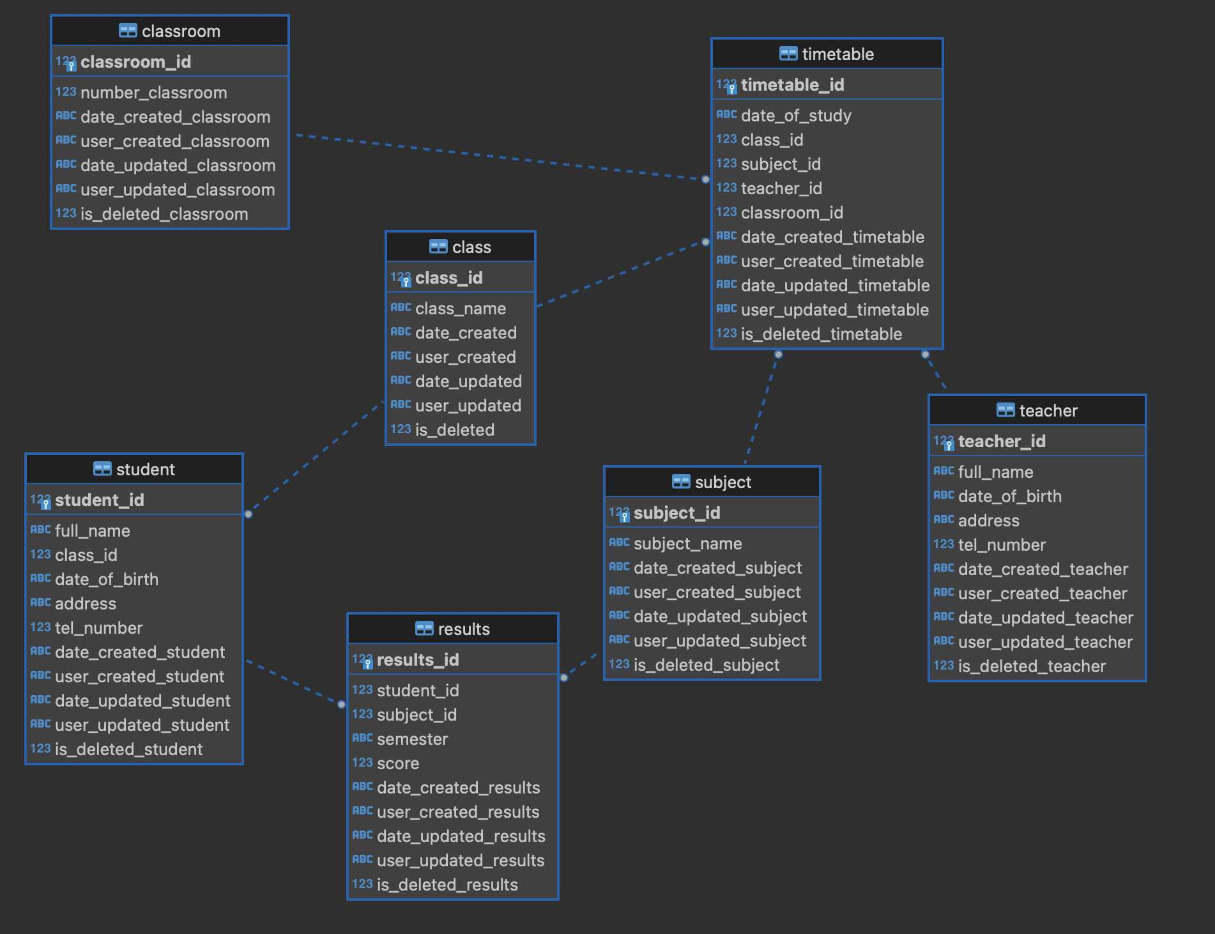

Код БД:

**CREATE** **TABLE** class (

class_id **INTEGER** **PRIMARY** **KEY** **AUTOINCREMENT**,

class_name **VARCHAR** (10) **NOT** **NULL**

, date_created **DATETIME**, user_created **VARCHAR**(50), date_updated **DATETIME**, user_updated **VARCHAR**(50), is_deleted **BOOLEAN**);

**CREATE** **TABLE** classroom (

classroom_id **INTEGER** **PRIMARY** **KEY** **AUTOINCREMENT**,

number_classroom **INTEGER** **NOT** **NULL**

, date_created_classroom **DATETIME**, user_created_classroom **VARCHAR**(50), date_updated_classroom **DATETIME**, user_updated_classroom **VARCHAR**(50), is_deleted_classroom **BOOLEAN**);

**CREATE** **TABLE** results (

results_id **INTEGER** **PRIMARY** **KEY** **AUTOINCREMENT**,

student_id **INTEGER** **NOT** **NULL**,

subject_id **INTEGER** **NOT** **NULL**,

semester **VARCHAR** (10),

score **INTEGER**, date_created_results **DATETIME**, user_created_results **VARCHAR**(50), date_updated_results **DATETIME**, user_updated_results **VARCHAR**(50), is_deleted_results **BOOLEAN**,

**FOREIGN** **KEY** (student_id) **REFERENCES** student(student_id),

**FOREIGN** **KEY** (subject_id) **REFERENCES** subject(subject_id)

);

**CREATE** **TABLE** student (

student_id **INTEGER** **PRIMARY** **KEY** **AUTOINCREMENT**,

full_name **VARCHAR** (30) **NOT** **NULL**,

class_id **INTEGER** **NOT** **NULL**,

date_of_birth **DATE** **NOT** **NULL**,

address **VARCHAR** (100) **NOT** **NULL**,

tel_number **INTEGER** **NOT** **NULL**, date_created_student **DATETIME**, user_created_student **VARCHAR**(50), date_updated_student **DATETIME**, user_updated_student **VARCHAR**(50), is_deleted_student **BOOLEAN**,

**FOREIGN** **KEY** (class_id) **REFERENCES** class(class_id)

);

**CREATE** **TABLE** subject (

subject_id **INTEGER** **PRIMARY** **KEY** **AUTOINCREMENT**,

subject_name **VARCHAR** (50) **NOT** **NULL**

, date_created_subject **DATETIME**, user_created_subject **VARCHAR**(50), date_updated_subject **DATETIME**, user_updated_subject **VARCHAR**(50), is_deleted_subject **BOOLEAN**);

**CREATE** **TABLE** teacher (

teacher_id **INTEGER** **PRIMARY** **KEY** **AUTOINCREMENT**,

full_name **VARCHAR** (50) **NOT** **NULL**,

date_of_birth **DATE** **NOT** **NULL**,

address **VARCHAR** (100) **NOT** **NULL**,

tel_number **INTEGER** **NOT** **NULL**

, date_created_teacher **DATETIME**, user_created_teacher **VARCHAR**(50), date_updated_teacher **DATETIME**, user_updated_teacher **VARCHAR**(50), is_deleted_teacher **BOOLEAN**);

**CREATE** **TABLE** timetable (

timetable_id **INTEGER** **PRIMARY** **KEY** **AUTOINCREMENT**,

date_of_study **DATE** **NOT** **NULL**,

class_id **INTEGER** **NOT** **NULL**,

subject_id **INTEGER** **NOT** **NULL**,

teacher_id **INTEGER** **NOT** **NULL**,

classroom_id **INTEGER** **NOT** **NULL**, date_created_timetable **DATETIME**, user_created_timetable **VARCHAR**(50), date_updated_timetable **DATETIME**, user_updated_timetable **VARCHAR**(50), is_deleted_timetable **BOOLEAN**,

**FOREIGN** **KEY** (class_id) **REFERENCES** class(class_id),

**FOREIGN** **KEY** (subject_id) **REFERENCES** subject(subject_id)

**FOREIGN** **KEY** (teacher_id) **REFERENCES** teacher(teacher_id),

**FOREIGN** **KEY** (classroom_id) **REFERENCES** classroom (classroom_id)

);

Код триггеров БД:

**CREATE** **TRIGGER** set_date_created **AFTER** **INSERT**

**ON** class

**FOR** **EACH** **ROW**

**WHEN** (**NEW**.date_created **IS** **NULL**)

**BEGIN**

**UPDATE** class **SET** date_created = **DATETIME**('now') **WHERE** class_id = **NEW**.class_id;

**END**;

**CREATE** **TRIGGER** set_date_updated **AFTER** **UPDATE** **OF** class_name

**ON** class

**FOR** **EACH** **ROW**

**WHEN** (**NEW**.date_updated **IS** **NULL**)

**BEGIN**

**UPDATE** class **SET** date_updated = **DATETIME**('now') **WHERE** class_name = **NEW**.class_name;

**END**;

**CREATE** **TRIGGER** set_is_deleted **AFTER** **DELETE**

**ON** class

**FOR** **EACH** **ROW**

**BEGIN**

**INSERT** **INTO** class (class_id, class_name, date_created, user_created, date_updated, user_updated, is_deleted)

**VALUES** (**OLD**.class_id, **OLD**.class_name, **OLD**.date_created, **OLD**.user_created, **OLD**.date_updated, **OLD**.user_updated, **True**);

**END**;

**CREATE** **TRIGGER** set_user_created **AFTER** **INSERT**

**ON** class

**FOR** **EACH** **ROW**

**WHEN** (**NEW**.date_created **IS** **NULL**)

**BEGIN**

**UPDATE** class **SET** user_created = 'teacher' **WHERE** class_id = **NEW**.class_id;

**END**;

**CREATE** **TRIGGER** set_user_updated **AFTER** **UPDATE** **OF** class_name

**ON** class

**FOR** **EACH** **ROW**

**WHEN** (**NEW**.date_updated **IS** **NULL**)

**BEGIN**

**UPDATE** class **SET** user_updated = 'expert' **WHERE** class_name = **NEW**.class_name;

**END**;

**CREATE** **TRIGGER** set_date_created_classroom **AFTER** **INSERT**

**ON** classroom

**FOR** **EACH** **ROW**

**WHEN** (**NEW**.date_created_classroom **IS** **NULL**)

**BEGIN**

**UPDATE** classroom **SET** date_created_classroom = **DATETIME**('now') **WHERE** classroom_id = **NEW**.classroom_id;

**END**;

**CREATE** **TRIGGER** set_date_updated_classroom **AFTER** **UPDATE** **OF** number_classroom

**ON** classroom

**FOR** **EACH** **ROW**

**WHEN** (**NEW**.date_updated_classroom **IS** **NULL**)

**BEGIN**

**UPDATE** classroom **SET** date_updated_classroom = **DATETIME**('now') **WHERE** number_classroom = **NEW**.number_classroom;

**END**;

**CREATE** **TRIGGER** set_is_deleted_classroom **AFTER** **DELETE**

**ON** classroom

**FOR** **EACH** **ROW**

**BEGIN**

**INSERT** **INTO** classroom (classroom_id, number_classroom, date_created_classroom, user_created_classroom, date_updated_classroom, user_updated_classroom, is_deleted_classroom)

**VALUES** (**OLD**.classroom_id, **OLD**.number_classroom, **OLD**.date_created_classroom, **OLD**.user_created_classroom, **OLD**.date_updated_classroom, **OLD**.user_updated_classroom, **True**);

**END**;

**CREATE** **TRIGGER** set_user_created_classroom **AFTER** **INSERT**

**ON** classroom

**FOR** **EACH** **ROW**

**WHEN** (**NEW**.date_created_classroom **IS** **NULL**)

**BEGIN**

**UPDATE** classroom **SET** user_created_classroom = 'teacher' **WHERE** classroom_id = **NEW**.classroom_id;

**END**;

**REATE** **TRIGGER** set_user_updated_classroom **AFTER** **UPDATE** **OF** number_classroom

**ON** classroom

**FOR** **EACH** **ROW**

**WHEN** (**NEW**.date_updated_classroom **IS** **NULL**)

**BEGIN**

**UPDATE** classroom **SET** user_updated_classroom = 'expert' **WHERE** number_classroom = **NEW**.number_classroom;

**END**;

**CREATE** **TRIGGER** set_date_created_results **AFTER** **INSERT**

**ON** results

**FOR** **EACH** **ROW**

**WHEN** (**NEW**.date_created_results **IS** **NULL**)

**BEGIN**

**UPDATE** results **SET** date_created_results = **DATETIME**('now') **WHERE** results_id = **NEW**.results_id;

**END**;

**CREATE** **TRIGGER** set_date_updated_results **AFTER** **UPDATE** **OF** student_id, subject_id, semester, score

**ON** results

**FOR** **EACH** **ROW**

**WHEN** (**NEW**.date_updated_results **IS** **NULL**)

**BEGIN**

**UPDATE** results **SET** date_updated_results = **DATETIME**('now') **WHERE** student_id = **NEW**.student_id **OR** subject_id = **NEW**.subject_id **OR** semester = **NEW**.semester **OR** score = **NEW**.score;

**END**;

**CREATE** **TRIGGER** set_is_deleted_results **AFTER** **DELETE**

**ON** results

**FOR** **EACH** **ROW**

**BEGIN**

**INSERT** **INTO** results (results_id, student_id, subject_id, semester, score, date_created_results, user_created_results, date_updated_results, user_updated_results, is_deleted_results)

**VALUES** (**OLD**.results_id, **OLD**.student_id, **OLD**.subject_id, **OLD**.semester, **OLD**.score, **OLD**.date_created_results, **OLD**.user_created_results, **OLD**.date_updated_results, **OLD**.user_updated_results, **True**);

**END**;

**CREATE** **TRIGGER** set_user_created_results **AFTER** **INSERT**

**ON** results

**FOR** **EACH** **ROW**

**WHEN** (**NEW**.date_created_results **IS** **NULL**)

**BEGIN**

**UPDATE** results **SET** user_created_results = 'teacher' **WHERE** results_id = **NEW**.results_id;

**END**;

**CREATE** **TRIGGER** set_user_updated_results **AFTER** **UPDATE** **OF** semester, score

**ON** results

**FOR** **EACH** **ROW**

**WHEN** (**NEW**.date_updated_results **IS** **NULL**)

**BEGIN**

**UPDATE** results **SET** user_updated_results = 'expert' **WHERE** semester = **NEW**.semester **OR** score = **NEW**.score;

**END**;

**CREATE** **TRIGGER** set_date_created_subject **AFTER** **INSERT**

**ON** subject

**FOR** **EACH** **ROW**

**WHEN** (**NEW**.date_created_subject **IS** **NULL**)

**BEGIN**

**UPDATE** subject **SET** date_created_subject = **DATETIME**('now') **WHERE** subject_id = **NEW**.subject_id;

**END**;

**CREATE** **TRIGGER** set_date_updated_subject **AFTER** **UPDATE** **OF** subject_name

**ON** subject

**FOR** **EACH** **ROW**

**WHEN** (**NEW**.date_updated_subject **IS** **NULL**)

**BEGIN**

**UPDATE** subject **SET** date_updated_subject = **DATETIME**('now') **WHERE** number_subject = **NEW**.number_subject;

**END**;

**CREATE** **TRIGGER** set_is_deleted_subject **AFTER** **DELETE**

**ON** subject

**FOR** **EACH** **ROW**

**BEGIN**

**INSERT** **INTO** subject (subject_id, subject_name, date_created_subject, user_created_subject, date_updated_subject, user_updated_subject, is_deleted_subject)

**VALUES** (**OLD**.subject_id, **OLD**.subject_name, **OLD**.date_created_subject, **OLD**.user_created_subject, **OLD**.date_updated_subject, **OLD**.user_updated_subject, **True**);

**END**;

**CREATE** **TRIGGER** set_user_created_subject **AFTER** **INSERT**

**ON** subject

**FOR** **EACH** **ROW**

**WHEN** (**NEW**.date_created_subject **IS** **NULL**)

**BEGIN**

**UPDATE** subject **SET** user_created_subject = 'teacher' **WHERE** subject_id = **NEW**.subject_id;

**END**;

**CREATE** **TRIGGER** set_user_updated_subject **AFTER** **UPDATE** **OF** subject_name

**ON** subject

**FOR** **EACH** **ROW**

**WHEN** (**NEW**.date_updated_subject **IS** **NULL**)

**BEGIN**

**UPDATE** subject **SET** user_updated_subject = 'expert' **WHERE** subject_name = **NEW**.subject_name;

**END**;

**CREATE** **TRIGGER** set_date_created_teacher **AFTER** **INSERT**

**ON** teacher

**FOR** **EACH** **ROW**

**WHEN** (**NEW**.date_created_teacher **IS** **NULL**)

**BEGIN**

**UPDATE** teacher **SET** date_created_teacher = **DATETIME**('now') **WHERE** teacher_id = **NEW**.teacher_id;

**END**;

**CREATE** **TRIGGER** set_date_updated_teacher **AFTER** **UPDATE** **OF** full_name, date_of_birth, address, tel_number

**ON** teacher

**FOR** **EACH** **ROW**

**WHEN** (**NEW**.date_updated_teacher **IS** **NULL**)

**BEGIN**

**UPDATE** teacher **SET** date_updated_teacher = **DATETIME**('now') **WHERE** full_name = **NEW**.full_name **OR** date_of_birth = **NEW**.date_of_birth **OR** address = **NEW**.address **OR** tel_number = **NEW**.tel_number;

**END**;

**CREATE** **TRIGGER** set_is_deleted_teacher **AFTER** **DELETE**

**ON** teacher

**FOR** **EACH** **ROW**

**BEGIN**

**INSERT** **INTO** teacher (teacher_id, full_name, date_of_birth, address, tel_number, date_created_teacher, user_created_teacher, date_updated_teacher, user_updated_teacher, is_deleted_teacher)

**VALUES** (**OLD**.teacher_id, **OLD**.full_name, **OLD**.date_of_birth, **OLD**.address, **OLD**.tel_number, **OLD**.date_created_teacher, **OLD**.user_created_teacher, **OLD**.date_updated_teacher, **OLD**.user_updated_teacher, **True**);

**END**;

**CREATE** **TRIGGER** set_user_created_teacher **AFTER** **INSERT**

**ON** teacher

**FOR** **EACH** **ROW**

**WHEN** (**NEW**.date_created_teacher **IS** **NULL**)

**BEGIN**

**UPDATE** teacher **SET** user_created_teacher = 'teacher' **WHERE** teacher_id = **NEW**.teacher_id;

**END**;

**CREATE** **TRIGGER** set_user_updated_teacher **AFTER** **UPDATE** **OF** full_name, date_of_birth, address, tel_number

**ON** teacher

**FOR** **EACH** **ROW**

**WHEN** (**NEW**.date_updated_teacher **IS** **NULL**)

**BEGIN**

**UPDATE** teacher **SET** user_updated_teacher = 'expert' **WHERE** full_name = **NEW**.full_name **OR** date_of_birth = **NEW**.date_of_birth **OR** address = **NEW**.address **OR** tel_number = **NEW**.tel_number;

**END**;

**CREATE** **TRIGGER** set_date_created_timetable **AFTER** **INSERT**

**ON** timetable

**FOR** **EACH** **ROW**

**WHEN** (**NEW**.date_created_timetable **IS** **NULL**)

**BEGIN**

**UPDATE** timetable **SET** date_created_timetable = **DATETIME**('now') **WHERE** timetable_id = **NEW**.timetable_id;

**END**;

**CREATE** **TRIGGER** set_date_updated_timetable **AFTER** **UPDATE** **OF** date_of_study, class_id, subject_id, teacher_id, classroom_id

**ON** timetable

**FOR** **EACH** **ROW**

**WHEN** (**NEW**.date_updated_timetable **IS** **NULL**)

**BEGIN**

**UPDATE** timetable **SET** date_updated_timetable = **DATETIME**('now') **WHERE** date_of_study = **NEW**.date_of_study **OR** class_id = **NEW**.class_id **OR** subject_id = **NEW**.subject_id **OR** teacher_id = **NEW**.teacher_id **OR** classroom_id = **NEW**.classroom_id;

**END**;

**CREATE** **TRIGGER** set_is_deleted_timetable **AFTER** **DELETE**

**ON** timetable

**FOR** **EACH** **ROW**

**BEGIN**

**INSERT** **INTO** timetable (timetable_id, date_of_study, class_id, subject_id, teacher_id, classroom_id, date_created_timetable, user_created_timetable, date_updated_timetable, user_updated_timetable, is_deleted_timetable)

**VALUES** (**OLD**.timetable_id, **OLD**.date_of_study, **OLD**.class_id, **OLD**.subject_id, **OLD**.teacher_id, **OLD**.classroom_id, **OLD**.date_created_timetable, **OLD**.user_created_timetable, **OLD**.date_updated_timetable, **OLD**.user_updated_timetable, **True**);

**END**;

**CREATE** **TRIGGER** set_user_created_timetable **AFTER** **INSERT**

**ON** timetable

**FOR** **EACH** **ROW**

**WHEN** (**NEW**.date_created_timetable **IS** **NULL**)

**BEGIN**

**UPDATE** timetable **SET** user_created_timetable = 'teacher' **WHERE** timetable_id = **NEW**.timetable_id;

**END**;

**CREATE** **TRIGGER** set_user_updated_timetable **AFTER** **UPDATE** **OF** date_of_study, class_id, subject_id, teacher_id, classroom_id

**ON** timetable

**FOR** **EACH** **ROW**

**WHEN** (**NEW**.date_updated_timetable **IS** **NULL**)

**BEGIN**

**UPDATE** timetable **SET** user_updated_timetable = 'expert' **WHERE** date_of_study = **NEW**.date_of_study **OR** class_id = **NEW**.class_id **OR** subject_id = **NEW**.subject_id **OR** teacher_id = **NEW**.teacher_id **OR** classroom_id = **NEW**.classroom_id;

**END**;

**CREATE** **TRIGGER** set_date_created_student **AFTER** **INSERT**

**ON** student

**FOR** **EACH** **ROW**

**WHEN** (**NEW**.date_created_student **IS** **NULL**)

**BEGIN**

**UPDATE** student **SET** date_created_student = **DATETIME**('now') **WHERE** student_id = **NEW**.student_id;

**END**;

**CREATE** **TRIGGER** set_date_updated_student **AFTER** **UPDATE** **OF** full_name, class_id, date_of_birth, address, tel_number

**ON** student

**FOR** **EACH** **ROW**

**WHEN** (**NEW**.date_updated_student **IS** **NULL**)

**BEGIN**

**UPDATE** student **SET** date_updated_student = **DATETIME**('now') **WHERE** full_name = **NEW**.full_name **OR** class_id = **NEW**.class_id **OR** date_of_birth = **NEW**.date_of_birth **OR** address = **NEW**.address **OR** tel_number = **NEW**.tel_number;

**END**;

**CREATE** **TRIGGER** set_is_deleted_student **AFTER** **DELETE**

**ON** student

**FOR** **EACH** **ROW**

**BEGIN**

**INSERT** **INTO** student (student_id, full_name, class_id, date_of_birth, address, tel_number, date_created_student, user_created_student, date_updated_student, user_updated_student, is_deleted_student)

**VALUES** (**OLD**.student_id, **OLD**.full_name, **OLD**.class_id, **OLD**.date_of_birth, **OLD**.address, **OLD**.tel_number, **OLD**.date_created_student, **OLD**.user_created_student, **OLD**.date_updated_student, **OLD**.user_updated_student, **True**);

**END**;

**CREATE** **TRIGGER** set_user_created_student **AFTER** **INSERT**

**ON** student

**FOR** **EACH** **ROW**

**WHEN** (**NEW**.date_created_student **IS** **NULL**)

**BEGIN**

**UPDATE** student **SET** user_created_student = 'teacher' **WHERE** student_id = **NEW**.student_id;

**END**;

**CREATE** **TRIGGER** set_user_updated_student **AFTER** **UPDATE** **OF** full_name, class_id, date_of_birth, address, tel_number

**ON** student

**FOR** **EACH** **ROW**

**WHEN** (**NEW**.user_updated_student **IS** **NULL**)

**BEGIN**

**UPDATE** student **SET** user_updated_student= 'expert' **WHERE** full_name = **NEW**.full_name **OR** class_id = **NEW**.class_id **OR** date_of_birth = **NEW**.date_of_birth **OR** address = **NEW**.address **OR** tel_number = **NEW**.tel_number;

**END**;

**Связи между таблицами:**

* Classroom-Timetable (1 к 1);
* Class-Timetable (1 к 1);
* Class-Student (1 ко многим);
* Student-Results (многие ко многим);
* Results-Subject (многие ко многим);
* Teacher-Timetable (многие ко многим).

**Запросы:**

1.UPDATE

**UPDATE** classroom **SET** number_classroom = 57

**WHERE** number_classroom = 135;

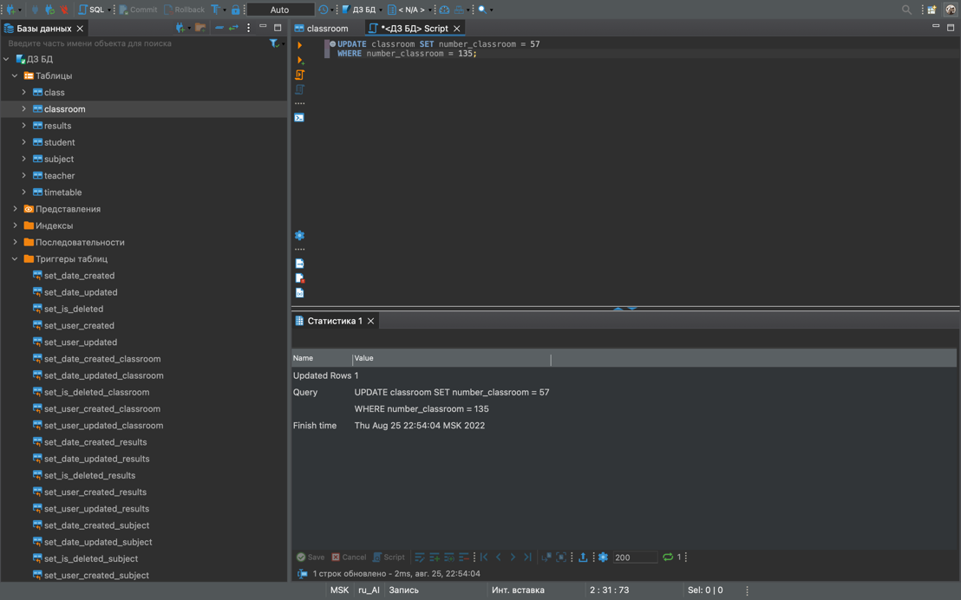

Работа триггера на UPDATE

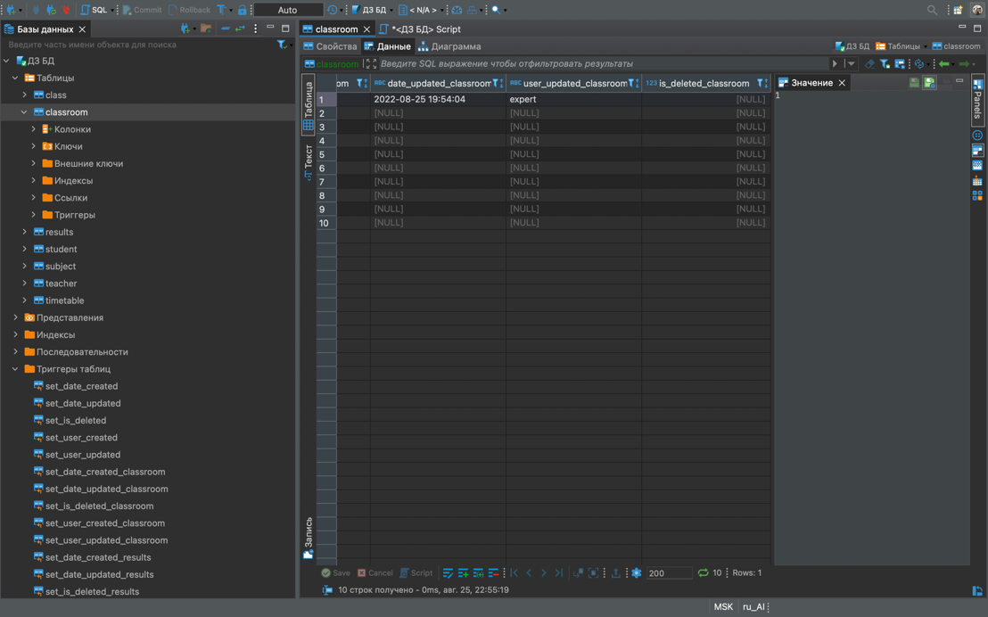

2. WHERE + IN

**SELECT** full_name, date_of_birth

**FROM** teacher t

**WHERE** address **IN** ('улица Петрова 12');

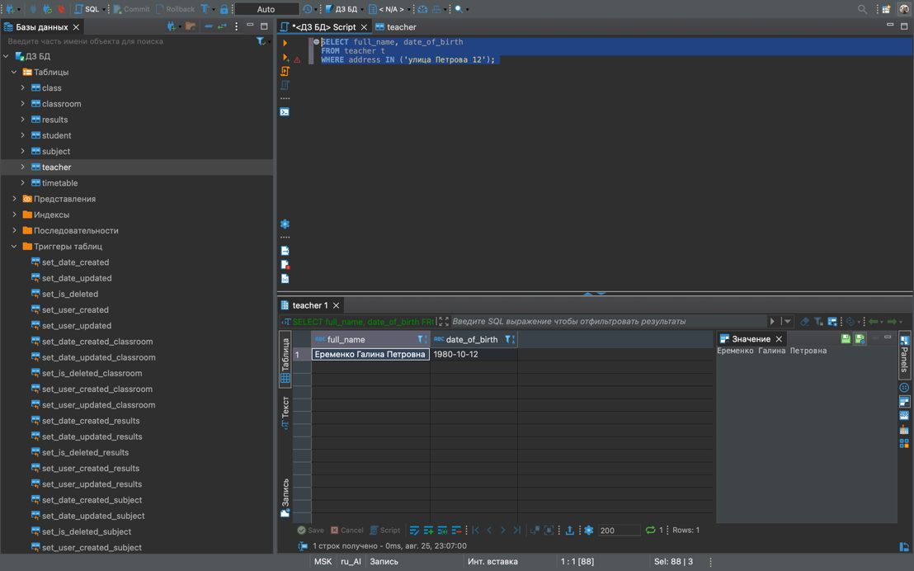

3. ORDER BY

**SELECT** full_name, date_of_birth, address

**FROM** teacher

**ORDER** **BY** full_name;

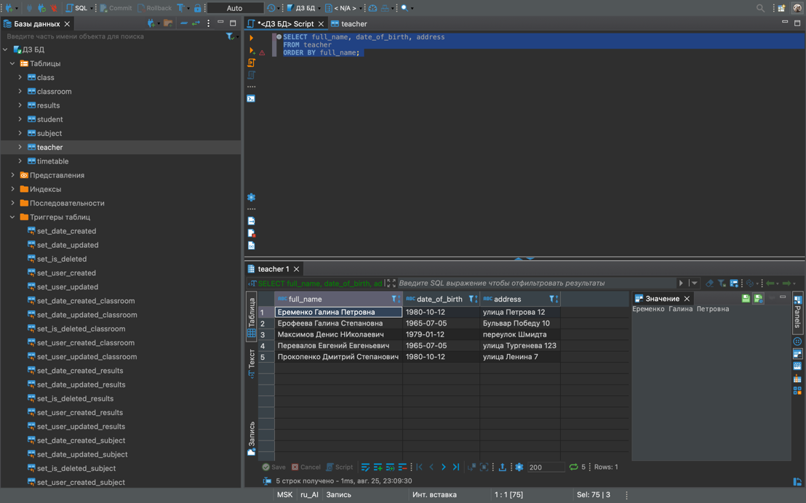

4. ORDER BY DESC

**SELECT** full_name, date_of_birth, tel_number

**FROM** student

**ORDER** **BY** full_name **DESC**;

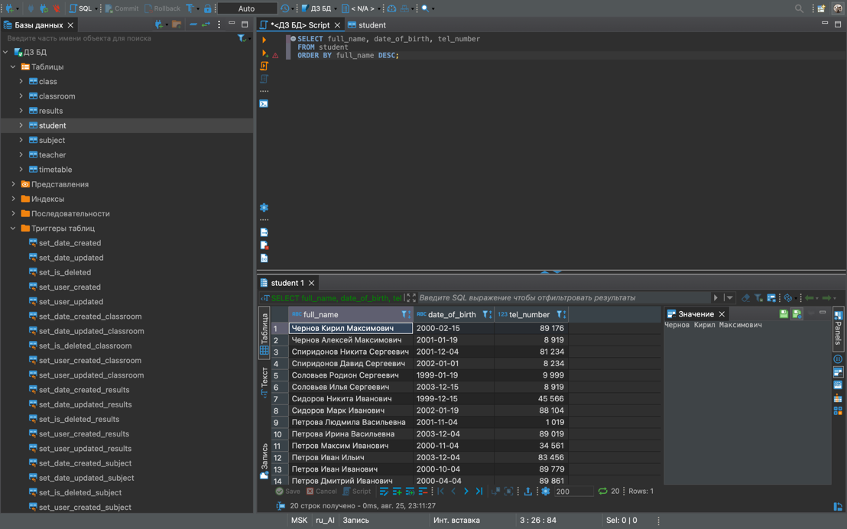

5. LIKE

**SELECT** * **FROM** teacher t

**WHERE** full_name **LIKE** '%а';

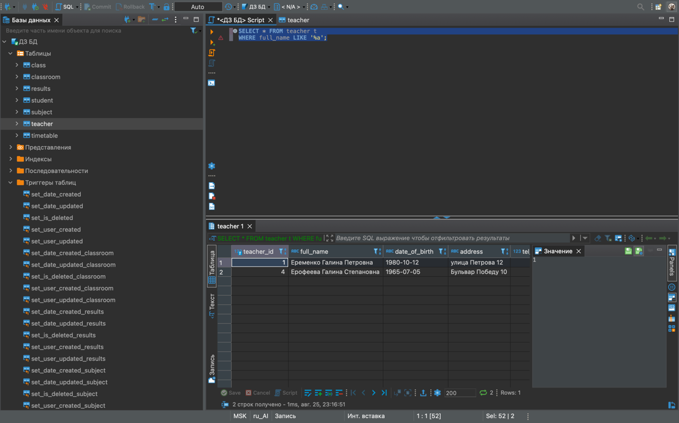

6. MIN

**SELECT** semester, **MIN** (score) **AS** min_score

**FROM** results r

**GROUP** **BY** semester;

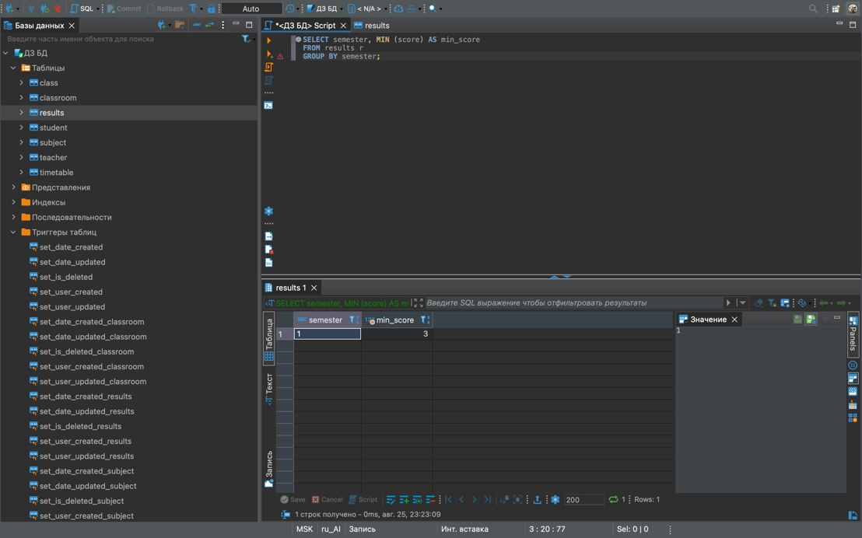

7. AVG

**SELECT** **AVG**(score) **AS** mid_score

**FROM** results r ;

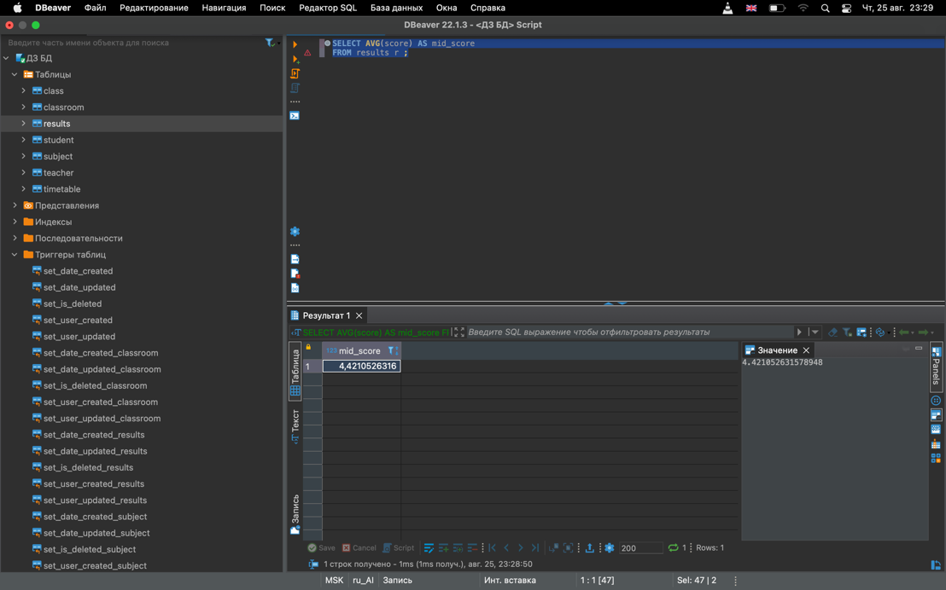

8. DELETE

**DELETE** **FROM** teacher

**WHERE** full_name = 'Максимов Денис НИколаевич';

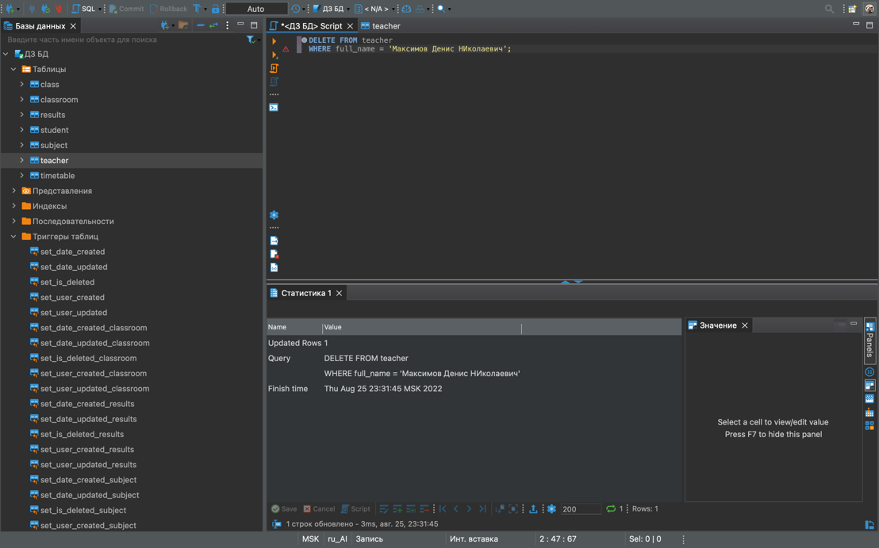

Работа триггера на DELETE

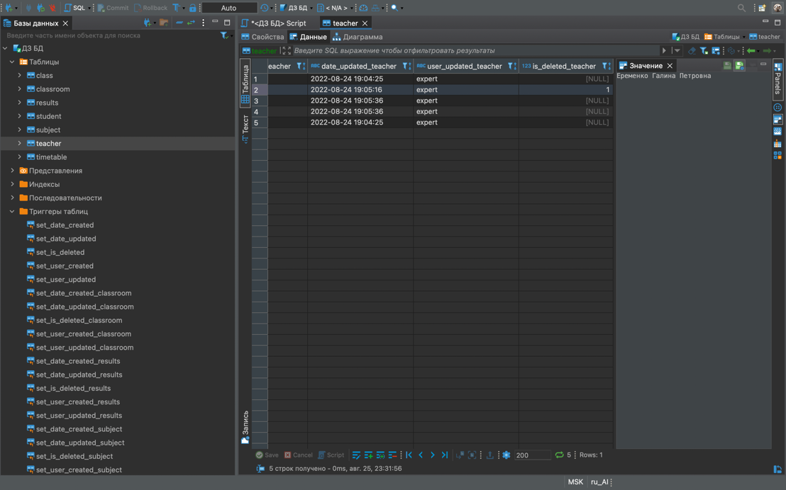

9. COUNT (*)

**SELECT** **COUNT**(*) **AS** total_student

**FROM** student s;

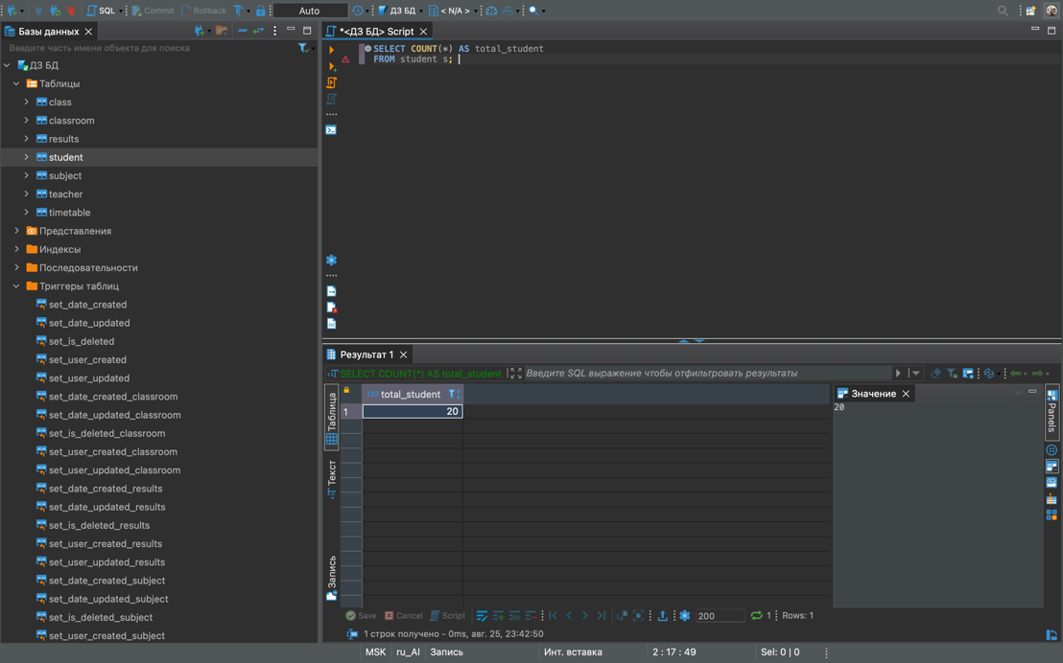

10. ORDER BY + LIMIT

**SELECT** *

**FROM** teacher t

**ORDER** **BY** date_of_birth

**LIMIT** 1;

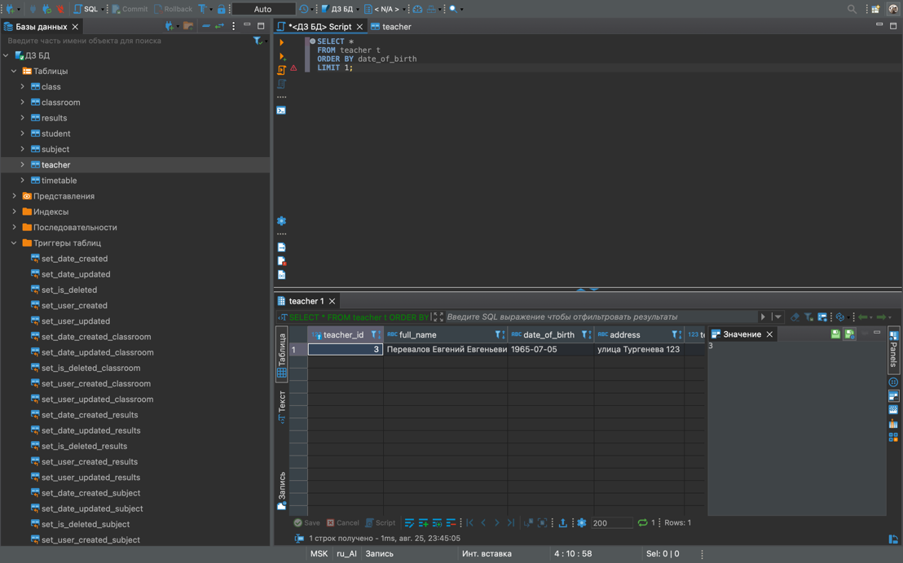

11. CROSS JOIN

**SELECT** full_name, score

**FROM**

student s **CROSS** **JOIN** results r;

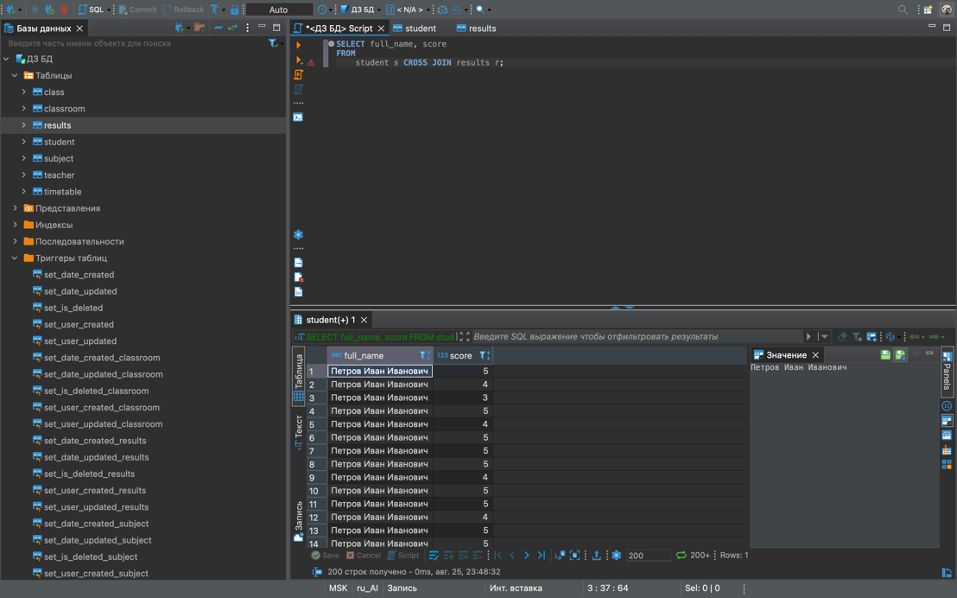

12. WHERE + OR

**SELECT** *

**FROM** teacher t

**WHERE** full_name = 'Перевалов Евгений Евгеньевич'

**OR** date_of_birth = '1980-10-12';

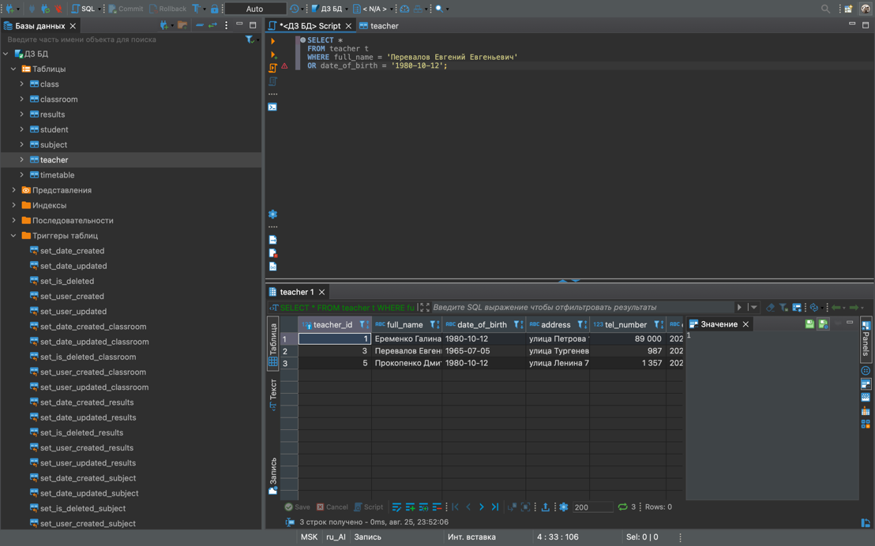

13. WHERE + NOT

**SELECT** *

**FROM** teacher t

**WHERE** **NOT** full_name = 'Перевалов Евгений Евгеньевич';

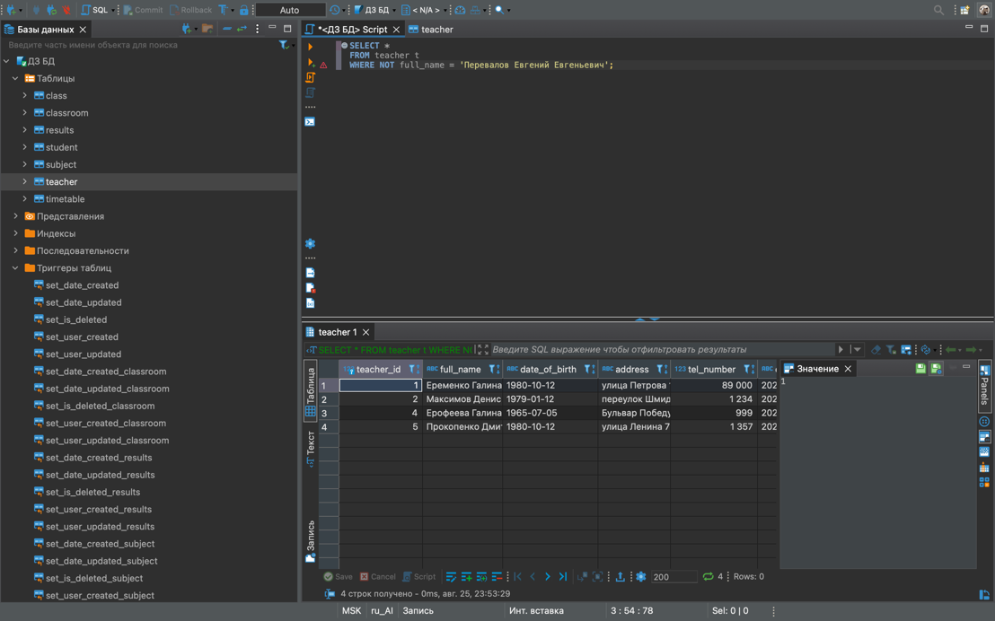

14. BETWEEN

**SELECT** full_name, score

**FROM**

student s **CROSS** **JOIN** results r

**WHERE** score **BETWEEN** 3 **AND** 4;

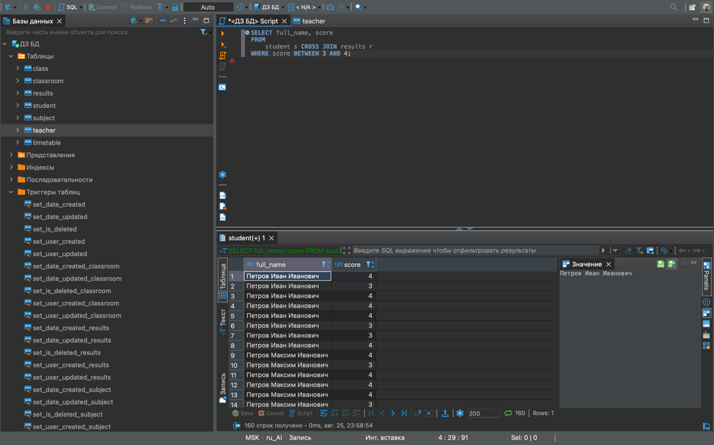

15. MIN, MAX

**SELECT** full_name, **MIN** (score) **AS** min_score, **MAX** (score) **AS** max_score

**FROM**

student s **CROSS** **JOIN** results r

**GROUP** **BY** full_name;

